

Europass  Curriculum Vitae |  | 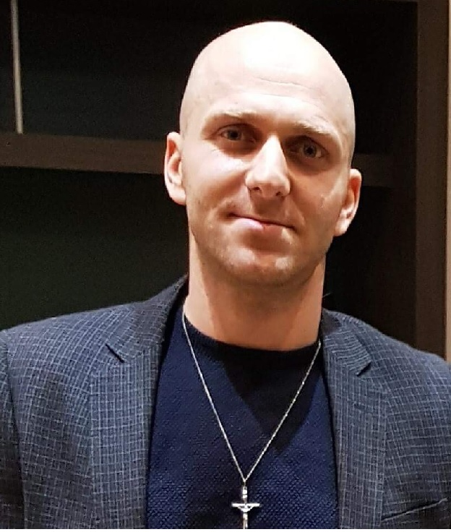
Personal information
First name(s) / Surname(s) |  | IOAN CORPADE
Address(es) |  | Str.Dorului no.127, Constanta, Romania
Telephone(s) |  | Mobile: +40 774 619 228
Fax(es) |  | N/A
E-mail |  | corpadeioan@gmail.com
Nationality |  | Romanian
Date of birth |  | 13/01/1986
Gender |  | Male
Objective  Desired employment / Occupational field |  | I have more than 8 years’ experience in bar and hospitality and over 5 years in entertainment business. I have worked both on cruise  I am a great team player and problem solver. My goal in life is success and growth. Working around the world with different ethnicity has broaden my knowledge and skills. I have great skills of leadership with a great sense of humour and patience, I speak 5 international languages, I adapt very well in different environments and always looking forward to new challenges. I have great skills in Management Supervising, bartending and Entertainment.  Bartender, Head Waiter, Restaurant Supervisor, Assistant MG, Cruise director, activity host.
Work experience |  | Date  16/10/2018 – 17/01/2020  Bartender barista and bar supervisor at Celebrity cruises line.  Running all type of bars, cafe bar, wine bars, martin bar and cocktail bar from opening to closing, in charge of the inventory, ordering stock and revenue of the bar, hosting wines testing and whisky testing as well as rum history and all information about rum ,world-wide whines, whisky and other liquor’s Teaching the bar servers about the cocktail’s and café making and using the machine, and supervise them with all the duties. Dealing with more than 2000 guest every day
Dates |  | 05/11/2016 – 10/02/2018
Occupation or position held |  | Bar and Restaurant Supervisor-AM
Main activities and responsibilities |  | Supervising the staff , ordering stock, making bookings , trying to bring new drinks in the menu, giving good energy to the staff and guest ,good communication with the manage regarding food and drinks and the atmosphere and music of the restaurant.
Name and address of employer |  | Nozomi Fine Dining and Refuto Fine Dining, Birmingham
Type of business or sector |  | Restaurant
  Dates
  Occupation or position held
  Main activities and responsibilities
  Name and address of employer
  Type of business or sector
  Dates
  Occupation or position held
  Main activities and responsibilities
  Name and address of employer
  Type of business or sector
  07/09/2013 – 24/08/2015
  Bar Supervisor / Bartender and Barista
  Bartending, preparing drinks, serving, supervising
  Aston Villa Football Club and West Bromwich Club / Cheltenham horse races, VIP bar Owners and Trainers
  Bartending All event around Birmingham and west midlands
  05/03/2012 – 20/07/2013
  Bartender-Barista and Waiter
  Serving clients and preparing drinks, taking orders and hosting.
  Fiesta del Asado Birmingham Argentinian fine dining
  Restaurant
  Dates
  Occupation or position held
  Main activities and responsibilities
  Name and address of employer
  Type of business or sector
  08.06.2008-10.01.2012
  Activity Host-Wedding singer,-DJ-MC
  Hosting games, knowledge trivia, sports activities-, yoga dance-classes. Interact with guest ,bingo games and shows, presentation.…
  Carnival Cruises line and Wedding Singer in Constanta town.
  Cruise Industry
ef
Education and training
Dates |  | 01/10/2015 – 01/06/2018
Title of qualification awarded |  | Licence degree
Principal subjects/occupational skills covered |  | Arts and Choreography
Name and type of organisation providing education and training |  | Ovidius University of Arts, Constanta, Romania
Level in national or international classification |  | National and international
  Dates
  Title of qualification awarded
  Principal subjects/occupational skills covered
  Name and type of organisation providing education and training
  Level in national or international classification
  15/09/2000 – 01/06/2004
  Bachelor degree
  Arts
  Regina Maria High School, Costanta, Romania
  National
Personal skills and competences
Mother tongue(s) |  | Romanian
Other language(s) |  | Italian, French – B1, A2
Self-assessment |  |  | Understanding |  |  |  |  | Speaking |  |  |  |  | Writing
European level (*) |  |  | Listening |  | Reading |  |  | Spoken interaction |  | Spoken production
English |  |  |  | C1 |  | C1 |  |  | C1 |  |  | C1 |  | B2
Spanish |  |  |  | C1 |  | C1 |  |  | C1 |  |  | C1 |  | A2
 |  | (*) Common European Framework of Reference for Languages
Social skills and competences |  | Good listener, non-verbal communication, open-minded, respectful, motivating, friendly personality and engaging.  Excellent communication skills gained through my experience working with a multi- cultural environment ( cruise ships)  Teamwork driven personality ( working actively in a team of 20 people)
Organisational skills and competences |  | Very good organization skills developed after working in a multi- cultural environment ( cruise ships), fast thinking, quick leaner and hard working.  Leadership, relationship building, entertainment, event planning, bar and restaurant stock inventory, creative thinking and Organising trivia games for groups.
Technical skills and competences |  | Sharp memory, good ability to read people, holding presentations.
Computer skills and competences |  | Basic user of pc, word, office.
Artistic skills and competences |  | Teaching dance classes, singing and stage performance, yoga and aerobics instructor and choreographer for both on land and in cruise ships.  Knowledge of variety of drinks and creating new recipes in the bar and restaurant industries.
Other skills and competences |  | Efficient and observant, knowledgeable in math, scientific works, history and philosophy thus giving me the opportunity to give interesting conversations with customers.  Speaks 5 language; English, Portuguese, Spanish, French and Italian.
Driving licence |  | B
Additional information |  | References on request

